**Experiment 7**

**Email Notifications in Jenkins**

**Aim**

To understand and practice setting up email.

**Steps**

1. Install Email Extension & Email Extension Template Plugin

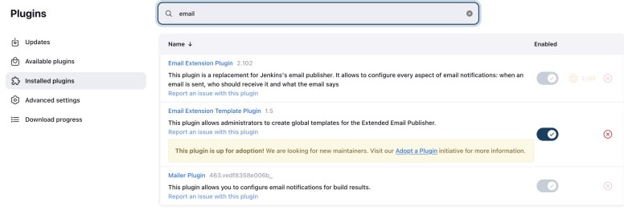

1. Configure the SMTP Server by going to Dashboard > Manage Jenkins >

System > Email Notification



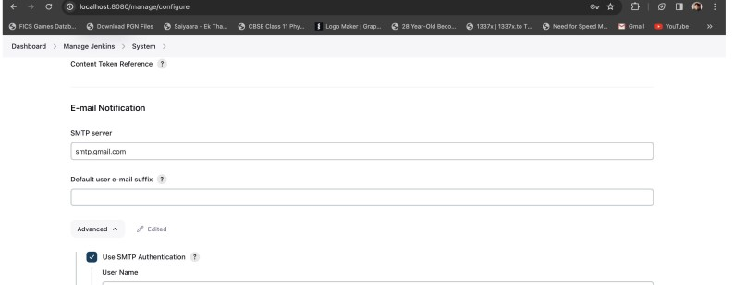

1. Create a job and add email in Build Settings

